GOD'S CHURCH
The Very Elect

‘DECLARING THE END FROM THE BEGINNING’
______________________________________________
Vol.1 No. 4 A BI - MONTHLY NEWSLETTER May-June 2017
___________________________________________________________________________________

A GLOBAL Phenomenon
of Hostility & Anger
_______________________________________________________________

The world is living through record times of HOSTILITY & Anger, in an era of extraordinary Protests, VIOLENCE, Chaos and social Disorder!

The Bible foretold these times, and all times of man’s history, his-story, man’s, was foreseen by The Almighty Creator, and though God instructed the first human-beings personally, yet they have ever rejected His Supreme Authority, & Godhead!

The Chaos we are seeing all over this troubled earth does not stem as men have supposed in their ignorance, from any other source than that of that old serpent called the Devil and Satan, the unseen ruler of this world, for God is not the author of confusion! (I Cor’s.14:33.)

Mankind is now being led to its own demise for almost 6,000 years of rebellion, disorder, and rejection of Gods Law, which is simply the-way of God’s love as the first 2-created humans did, even though they were instructed firsthand.

Just as ancient Israel did repeatedly!!

Take for example, the prophetic words of the apostle to the Gentiles, in the book of Romans chapter 1;

“Because that when they knew God, they glorified Him not as God, neither were thankful; but became vain in their imaginations, and their foolish heart was darkened. Professing themselves to be wise, they became fools! (Rom’s.1:21-22.)

Any who do not know the facts of mankind’s fall and the resulting chaos that has filled this earth ever since, only need stand back and look at the fruits of man;

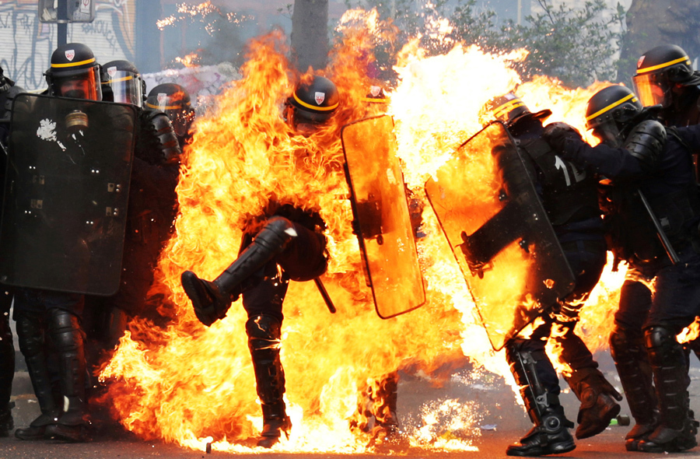

Violence, anger, hostility, hatred, destruction, war, disease, pestilence, the absence of peace in this world everyone recognises, yet, not one of its leaders knows the-way to achieve peace!

The effects of mans’ rejections of God’s way, fill the earth, but man only wants to deal with the effects, never the causes!!

Take for example the disintegration of the family unit into an abominable thing, the loss of the God ordained father figure, and head of the family, even the degeneration of humankind’s genders, now eroded and watered down into something so corrupted, we’re scratching our heads to comprehend how humans could pervert such things, where people can “identify” themselves as whatever they wish, regardless of their gender.
The whole situation has become so ludicrous, that normal heterosexuals are being accused of “gender-bias” by disagreeing with this rot!
Everyone has to have their “rights” you see. No! They have their rights, we aren’t allowed to voice our disagreement in any way without being seen as being discriminatory in some weird way.

It seems that almost every value, moral and decent thing meant for man’s own good has been trashed and assigned to the waste-bin, like some old rag doll discarded, as “old-thinking”, and no-longer useful in a world of “progress”?

One of the “new-norms” appears to be to protest, scream, rant and rave like spoilt little brats until you get what you want!
How such a wonderful creation as mankind is, with the capacity to build great towers, bridges, tunnels, even spacecraft that can reach into outer-space, not have the ability to govern himself in peace, order and stability, seems too incredible in the face of all this awesome advancement!

But, when we put all of this “advancement” up against the prism of truth from The Word of God, we find an all-together different reality.

The fact that though mankind mostly says he hates what he sees with social unrest, rioting, race-wars, violence, rape, child molestation, paedophilia, incest and other horrific crimes against women, children of both sexes, (even though there isn’t really a male or female gender anymore, just whatever you decide.) just some of the fruits of man’s evil legacy, yet the truth which is stranger than fiction informs us of this reality, that they like it that way!

If they didn’t like it that way, they would tell successive “Gov’ts” of their disgust at the changes being foistered upon them without their agreement. Gov’ts like snake-oil salesmen will sell you, the customer whatever you will buy, just as our Governments allow tobacco giants to ply their evil trade upon the people for their own greedy gain, even though their products cause cancers and death, they, the “Gov’ts” couldn’t care less because they accept bribes from the merchants of this world, who ply them with monetary incentives called “taxes”!

And all this from duly elected officials who are meant to have the best interests of the citizens over whom they preside at heart???

Astonishingly, like actors in a play where blanks should have been used, live ammunition was substituted, and used by the players on one another, where a great puppeteer dazzled the actors and the audiences with bright lights and slight of hand, like some broken record stuck on the same track of a never-ending song!

What is the answer to these and ALL of man’s seemingly endless problems?

Could it be that we need more progress in the form of technology as the clueless youth so often think?

Could it be more great weapons of mass destruction to instil fear in our enemies?

Perhaps it’s the need for a One-World power that could alleviate all starvation, disease epidemics, fear of war, of crime and all violence??

To all who fear God, hear well this truth that I write to you now;

Man of himself CANNOT Know The-Way to peace, to prosperity to safety, to wholesome industrious productivity.
The-ways that will always elude man, the very God they reject teaches that to accept Christ is to accept LIFE-ETERNAL!!!
To reject God while accepting mankind’s guidance and leadership, his ways and thinking, is to seek every evil way, anger, violence, confusion, lies and deception, misery are in their paths, pain and suffering is the order of the day.

But to seek God and His kingdom, is to seek the love of Christ which surpasses all understanding. The Truth, of God frees the sinner, the God-rejecter from the LIES that mankind prefers to believe.

Incredibly, man calls God a lie, but believes the infantile lie of Darwin’s evolutionary theory over creation rather than believe the truth because man has invented for himself a false science, that is based on theories rather than the rue-science of creation, provable throughout the entire earths geological topography!

The facts of the very science they say they use actually proves their juvenile theories wrong, and if God lies in His Word, then no-man has any basis for faith, and therefore somehow burst into existence through the theoretical conjecture of man’s mind.

If that is true, then all faith is VAIN, you and I have no basis for our beliefs, whether proven or not, because theory is apparently truth, and fact is “falsehood”, turning every known element on its head.

To the radicals, the angry, the violent God haters and rejecters of this world, God, not I says;
Heb.6:18 So that by two unchangeable things, in which it is impossible for God to lie, …This is the main point, it is IMPOSSIBLE for God to LIE!)

Notice what this servant of God was inspired to write many centuries ago regarding this mind, as incredible as it is with tremendous abilities such as man possess, yet is so utterly unable to change of himself!

Why?

The Word of God teaches and reveals to any with eyes to see, that the mind of man is utterly unable to comprehend such simple things as this because he has a mind REFUSES to SUBMIT to The Law of God!
The ESV renders it this way;
Rom 8:7 For the mind that is set on the flesh (Matters do not pertain to The Spiritual matters of God’s Living Word) is hostile to God, for it does not submit to God's law; indeed, it cannot.

That’s #1 Truth!

The Son of God Himself said that mankind cannot accept TRUTH! Mankind would not believe or accept that fact, nevertheless, God is true and every man a liar as other inspired scripts reveal.
Rom 3:3 For what if some did not believe? shall their unbelief make the faith of God without effect?
Rom 3:4 God forbid: yea, let God be true, but every man a liar; as it is written, That thou mightest be justified in thy sayings, and mightest overcome when thou art judged.

Even though mankind have always proven false, liars, covenant breakers, fraudsters and deceivers, yet man in his “perfect” state still has the arrogance to accuse HIS OWN CREATOR of being just something made up by some old Jews, and therefore there is no-GOD??

What does The Word of God tell the World in response?

“The FOOL has said in his heart there is no God” ……(Psalm.53:1)

Remember, “All Scripture is given by inspiration of God” (II Tim.3:16)
And, “Sanctify them through thy truth: thy word is truth”. John.17:17

As the rest of Psalm.53:1 concludes …Corrupt are they, and have done abominable iniquity: there is none that doeth good.

The world out of which God’s people have been called today, and by “God’s people today”, I mean “Spiritual-Israel”, not physical Israel, although there are elements of both, they know and believe that The Bible is the inspired Word of God, and strive to live by every Word thereof, not perfectly by any means, but trying to put The Word of God into practice with patience, hope and faith!

Isn’t that what the definition of a “Christian” really is? One that really strives to follow God through The Word OF God via Jesus Christ, who is incidentally, The Word also.

And the servant of the same LORD of all the earth inspired this writing we read here below, as with all scripture.
Why?
2Ti 3:16 All scripture is given by inspiration of God, and is profitable for doctrine, for reproof, for correction, for instruction in righteousness:
To LIVE by! That’s #2 Truth.

The fact is that the world out of which we have been called brethren, does NOT know, neither CAN “it” KNOW The way of TRUTH, for it is IMPOSSIBLE for ANY to come to the knowledge of the Truth Apart from The Spirit of GOD!!

That’s another fact as spelled in John.6:63. It is the spirit that quickeneth; (Makes alive) the flesh profiteth nothing: the words that I speak unto you, they are spirit, and they are life.
The blinded of this world say all too often; “Oh well, what can you do?”;
Think about that in terms of homosexuals, “aren’t doing me any harm”…
Today, they form much of the protest movements, lately added to them by the LGBT brigade, “equal-rights/marriage” etc, etc, etc….
As these individuals push and shove everyone around and over, in their quest fro “freedom”, and “rights”, we are inevitably being shoved aside in the stampede to “enlightenment” and “progress”!

Is this really progress, and are we so blinded, we can’t see the damage all of these sick “symptoms” are showing us??

The prophet Isaiah stated of God’s people approximately 2,700-2,750 years ago that they were a sinful nation, laden with INIQUITY, a seed of evil doers, children that had forsaken The LORD, provoking Him to anger, they are gone away BACKWARD.

Even telling them that they were so completely sick from the sole of the foot, to the top of the head, with no soundness in it; but wounds, and bruises, and purifying sores!

Further into this dressing down and warnings of a coming desolation, they were addressed as the rulers of Sodomites! (Isa.1:4-10.)

The prophets often spoke to Israel of the catastrophe that would await them if they refused to heed the warnings sent to them, but they refused.

In today’s modern technological world, apparently values are classed as “old-world”, no longer applicable. The youth all “think” they know everything already, because technology makes them wise, and the older generations are just fuzzy in the brain of course.
As for the ancient texts quoted herein, and the wisdom of them, both young and “old” in this world not only reject, but mostly turn away and deride anyone having a “belief” in this manual-for-life, called the Holy Bible.
Were the scriptures therefore only for old-testament times, you know, for old-folks, for former generations, for old-school people a little backward, superstitious or just silly, and how could those old texts apply to the anger, hostility and problems we’re seeing in our “modern-world”?

Weren’t those prophets just warning the people to turn them from their evil ways way back then, or were they a set of now prophecies, for today??
How could that ever be possible?

One such servant, was sent to be a prophet to the nations, to rot out, and to pull down, and to destroy, and to throw down, to build and to plant! One of the most amazing of all commissions given to any man!

Just read the following remarkable assignment given to him.

Jer 1:10 See, I have this day set thee over the nations and over the kingdoms, to root out, and to pull down, and to destroy, and to throw down, to build, and to plant.

These texts inform us that Jeremiahs commission extended not just nationally, or internationally, but over Epochs of time and kingdoms coming right down to the last generation of man and BEYOND!

Take for example what God inspired Jeremiah to write of a time far off into the future; Could any man do this? In this prophecy, God foretold how HE would raise up a faithful man, a man mentioned in the New Testament book of Acts.13:22, as a man after HIS own heart, that HE would raise up to be the one shepherd over all Israel, and a prince and a king, speaking of David
Jer 30:9 But they shall serve the LORD their God, and David their king, whom I will raise up unto them. (To raise him up, means resurrect at that time.)

Jer 30:10 Therefore fear thou not, O my servant Jacob, saith the LORD; neither be dismayed, O Israel: for, lo, I will save thee from afar, (Talking about the time far off into the future.) and thy seed from the land of their captivity; and Jacob shall return, and shall be in rest, and be quiet, and none shall make him afraid.
Jer 30:11 For I am with thee, saith the LORD, to save thee: though I make a full end of all nations whither I have scattered thee, yet will I not make a full end of thee: but I will correct thee in measure, and will not leave thee altogether unpunished.

Incredibly, God spoke similarly about this faithful servant way off into a future time, when mankind will have to come to accept their own-creator God, even His eternal Laws, when at that time David and others will be ruling.
Notice one such tremendous prophecy from another prophet, for that time, when mankind will be under righteous authority as God designates!

Eze 37:21 And say unto them, Thus saith the Lord GOD; Behold, I will take the children of Israel from among the heathen, whither they be gone, and will gather them on every side, and bring them into their own land:
Eze 37:22 And I will make them one nation in the land upon the mountains of Israel; and one king shall be king to them all: and they shall be no more two nations, neither shall they be divided into two kingdoms any more at all:
Eze 37:23 Neither shall they defile themselves any more with their idols, nor with their detestable things, nor with any of their transgressions: but I will save them out of all their dwellingplaces, wherein they have sinned, and will cleanse them: so shall they be my people, and I will be their God.
Eze 37:24 And David my servant shall be king over them; and they all shall have one shepherd: they shall also walk in my judgments, and observe my statutes, and do them.

The fact that God’s ancient people whom He chose for Himself rejected both Him and His instructions from the very beginning, although not surprising, gives anyone with a reasonable dose of common-sense, the “heads-up” that the prophets, the servants of our God were sent to guide, to correct and help save them out of all their problems, woes and even death IF they would only heed the counsel of The Most High
In today’s “vibrant” modern world where the ancients are nothing more than “old-fogies” who are too old to understand the young and the modern world, where the old-ways are never accepted by the young.

And yet, God’s counsel speaks volumes against this erroneous “thinking”!

Jer 6:16 Thus saith the LORD, Stand ye in the ways, and see, and ask for the old paths, where is the good way, and walk therein, and ye shall find rest for your souls. But they said, We will not walk therein.
The warnings have been as many, and varied as mankind himself, but still, he refuses through every generation, and every nation on the face of the earth!

Jer 6:18 Therefore hear, ye nations, and know, O congregation, what is among them.
Jer 6:19 Hear, O earth: behold, I will bring evil upon this people, even the fruit of their thoughts, because they have not hearkened unto my words, nor to my law, but rejected it.

This was squarely aimed at ancient Israel, but applies to all mankind, given the first 2-humans had been instructed in God’s Laws, or they could not have SINNED, because SIN is The TRANSGRESSION of The LAW, (I Jn.3:4) and the penalty for sin is DEATH which God had promised them if they ate of the tree of the knowledge of good and evil!

In the book of Jeremiah, the text often flips from the current nation of Israel to the “nations”, from the inhabitants of the land, to the daughter of God’s people, to the abominable who know no shame, to the nations of the earth of all the evil that The Eternal God has purposed to bring upon them for all the fruit of their thoughts and doings, because they all refuse to hearken to God’s Words, nor to His Law!!!

There are many such powerful pronouncements, time after time, generation after generation throughout the entire Bible, culminating with a consumption decreed to occur in a time ahead that will result in a world war so horrific, and graphic in detail that screams aloud to all inhabitants of this present evil generation, that it will soon be completely removed an destroyed!

WHAT IS COMING TO THE MODERN TRIBES OF ISRAEL, THE-WEST?

Where are we directed to see this in The Word of God? Well, many places actually, but to pinpoint at least some of the action that will begin to take place, we can readily identify first the signs of the times, then we will be able to connect causes with effects, and then connect God’s identifiable prophecies with current or even right up to date events that are playing out right before our eyes….
Rev 11:18 And the nations were angry....

The nations are Angry brethren, and it’s going to get FAR WORSE, as The first part of Rev.11 tells us, just before the time of The Coming Great Tribulation that the time is shorter than we may have supposed!

Even though men have continually guessed at this time, even the church wrongly thought the Great Tribulation was very close during the Cuban Missile crisis back in 1962, or the financial crash of 1973-75, Christ will NOT come as human-beings “think”, and even those with a measure of the Holy Spirit may be surprised at how it all turns out, of that I am personally convinced!

As part of the anger we are seeing all over the world in rising violence and social disorder, always realise who is back of this worlds crises, riots, and protests is Satan’s anger being poured out on an unsuspecting human kind, through every nation, but particularly Israel, as we see the day draw closer to the return of Jesus Christ!

E.U BEING FORCED TO RE-ORGANISE

With this impending time of Israel’s soon coming time of trouble, read relations between the US and Russia, the US and China, the UK and the EU, including Scotland’s desire to depart from the UK, the Brexit vote in England, and the convulsions that have seized many in Europe including the Pope during this tumultuous time particularly in recent months.

In this frame, picture the masses of mixed peoples seeded throughout those nations, and the problems they bring to their hosts, both individually, and collectively. Why? Because that is what the E.U want with the control of their host nations as part of their membership. Uncontrolled borders, control of member nations currencies because with this control they have power of their economies!

If this isn’t scary enough, they also have power over member nations Parliaments and therefore Laws, including having the autonomy to command their armies into war, and prevent them from assisting and backing long-time allies, including the U.S and Israel!

This has proven to be a major problem during the Obama administration, but now that Mr. Trump has assumed control, (although it is still under barrage of fire from the left) relations with many have been repaired, whilst others are still undecided, including China.
As for those NATO promised to protect against their enemies, including the Ukraine in the Crimean peninsula who gave up their nuclear weaponry in the belief that their agreement with the U.S was solid.
This proved to be a false confidence under Obama who did nothing when the Crimean Peninsula was annexed by the Russians in 2014.

Hopefully under Mr. Trump, this will quickly change.

As for the E.U and their aims, unfettered borders, financial control, without question many of the serious problems we are seeing in massive protests, God has said by the mouth of the prophet Ezekiel;
Eze 7:25 Destruction cometh; and they shall seek peace, and there shall be none.
Eze 7:26 Mischief shall come upon mischief, and rumour shall be upon rumour; then shall they seek a vision of the prophet; but the law shall perish from the priest, and counsel from the ancients. mischief shall come upon mischief,

The problems the modern nations of Israel are soon to face will completely pale everything we are now seeing into nothingness!
And what all of the illegal immigration and people movements through wars, disease epidemics and other reasons have all been foreseen. For that we can be grateful, because God has promised protection to His faithful people, and we kn ow He CANNOT lie.

The protests coming from the serial left, illegal immigrants, for example when financial aid is removed by incoming Governments such as Mr. Trump has rightly done, they will protest, even though they are meant to have integrated into their host-nation. The problems must be without number, but we know that there is coming a time when all of this will come to an end, and then shall all hell break loose!

WHERE DID IT ALL BEGIN?

For too many years, most if not all western nations, including Australia, Sweden, Switzerland, New Zealand, Canada, etc, have been bending over backwards to accommodate the foreign incursion, and the softer the west has become, the more vitriolic the aliens have become.
And brethren, we know all too well, that they often come in meek and mild, until they get their residency, then the problems begin. And they also begin their own political movements and parties due to the numbers of their own people supporting them, and the strife becomes worse. From there Gov’ts begin to listen to them more than the natural citizens of the nation, because they like a squeaky door need to be dealt with urgently, and the needs of their own people take 2nd place.
One of the reasons illegal immigration has become such a big issue, particularly in Europe, is the massive movement of middle eastern people into various parts of Europe, including Germany and Italy.
Among that mix there will no doubt be terrorists, because 1st, their identities cannot, simply cannot be verified as to who has fled ISIS, or Daish, or whether they are ordinary folks never involved in the fighting, sympathiser or non-sympathiser.
Germany, France and Sweden have had to learn this the hard way with their citizens being attacked by Somalians, Moroccans, Syrians, Iraqi’s etc, etc, but still, they pigheadedly refuse to stop them coming.

This has been one of the catalysts for Britain with the Brexit vote to leave the EU, because she, Britain wants to secure her own borders, not be told who can come in without so much as a by-your leave.
Secondly, Britain has now begun the long haul of securing her own currency, the pound sterling and her own economy again. That will be fraught with huge obstacles, given the financial agreements that will inevitably need to be unwound, but we will wait to see all of the demonstrations by the loony-left in Britain, but especially mark the numbers of foreigners, middle eastern and also, Europeans who want freedom of movements.

Brethren, if nothing else, this alone was a good idea to leave the EU, because all they have done in the past is lay out the welcome mat to terrorists with this foolhardy open door policy!

THE NEW PARADIGM – LEFT-WING PROTESTORS!
Certainly, the anger in Europe, in the US, in Canada at the US for its new foreign policies and immigration Laws, in Britain, in Russia, in the Ukraine, in many, many parts of the world has been splashed all over our television sets and in our news every week, and getting worse by the day!

For this, read, Anti-Trump demonstrators pepper spraying pro-Trump supporters, to an actress, a former show hostess, and the daughter of former secretary of state all considering “running for office”, to Mad as a cut snake Michael Moore warning of human-extinction because of Trump!

Then Sanctuary cities defying Federal Law and the President of the United States for harbouring illegal aliens, to so-called “Professors”, male & female making statements that defy all logic and reason.

One such instance, (there are many) is that of A Pennsylvania college professor who said he wanted to "vomit" after an airline passenger gave up a first-class seat for a uniformed member of the armed forces, Heat Street reported.

The Drexel University (in Philadelphia) Professor George Ciccariello-Maher, (one of these 2-named kids from modern marriages where the female partner won’t take her husbands name) who was criticized last Christmas for saying the only gift he wanted was "white genocide", said he wanted to "yell about Mosul" when he saw the act of kindness on the plane.

Then there’s the Dallas high school teacher who has been suspended for a video showing her shooting a squirt gun at a projected image of President Donald Trump from his Inauguration.
During the ‘mock assassination’, Payal Modi, an art teacher (Of Indian origin.) at Adamson High School, can be heard screaming "Die!" as she shoots the gun at a whiteboard projecting the Inauguration coverage, according to Fox 4 Dallas.

Consider for a moment what’s going on in the mind of a Massachusetts female State Rep. Michelle DuBois (D), who it is reported that she posted an online (Facebook) warning to illegal immigrants about an upcoming Immigration and Customs Enforcement (ICE) "raid."

The Sheriff of MA county said, “This is the most outrageous, outrageous example of what is going on across the United States that is undermining my job and every other law enforcement officer in the United States,” Hodgson said.

He went on to say; “Our citizens would be safer if we never stopped enforcing immigration law and if we never formed or turned a blind eye toward sanctuary cities,” Hodgson said.

“If these sanctuary cities are going to harbor and conceal criminal illegal aliens from ICE, which is in direct violation of Title 8 of the U.S. Code, federal arrest warrants should be issued for their elected officials,” Hodgson declared.

You see, that’s what happens when you take your eye off the ball, you know what happens?
It smacks you right in the face, or breaks a finger, because you’re too busy looking the other way!

Then you have another frivolous female, this time a Democratic Representative from I believe it is California, her name is Maxine Waters, one of the most vocal democrat representatives, and she “Tweeted” by social media for the President of the USA to get ready for impeachment!

What happened to respect for an office, even if you don’t respect the man, respect the office!! They are without bound, as we recently heard in a study Isa.3: epitomizes this situation well.
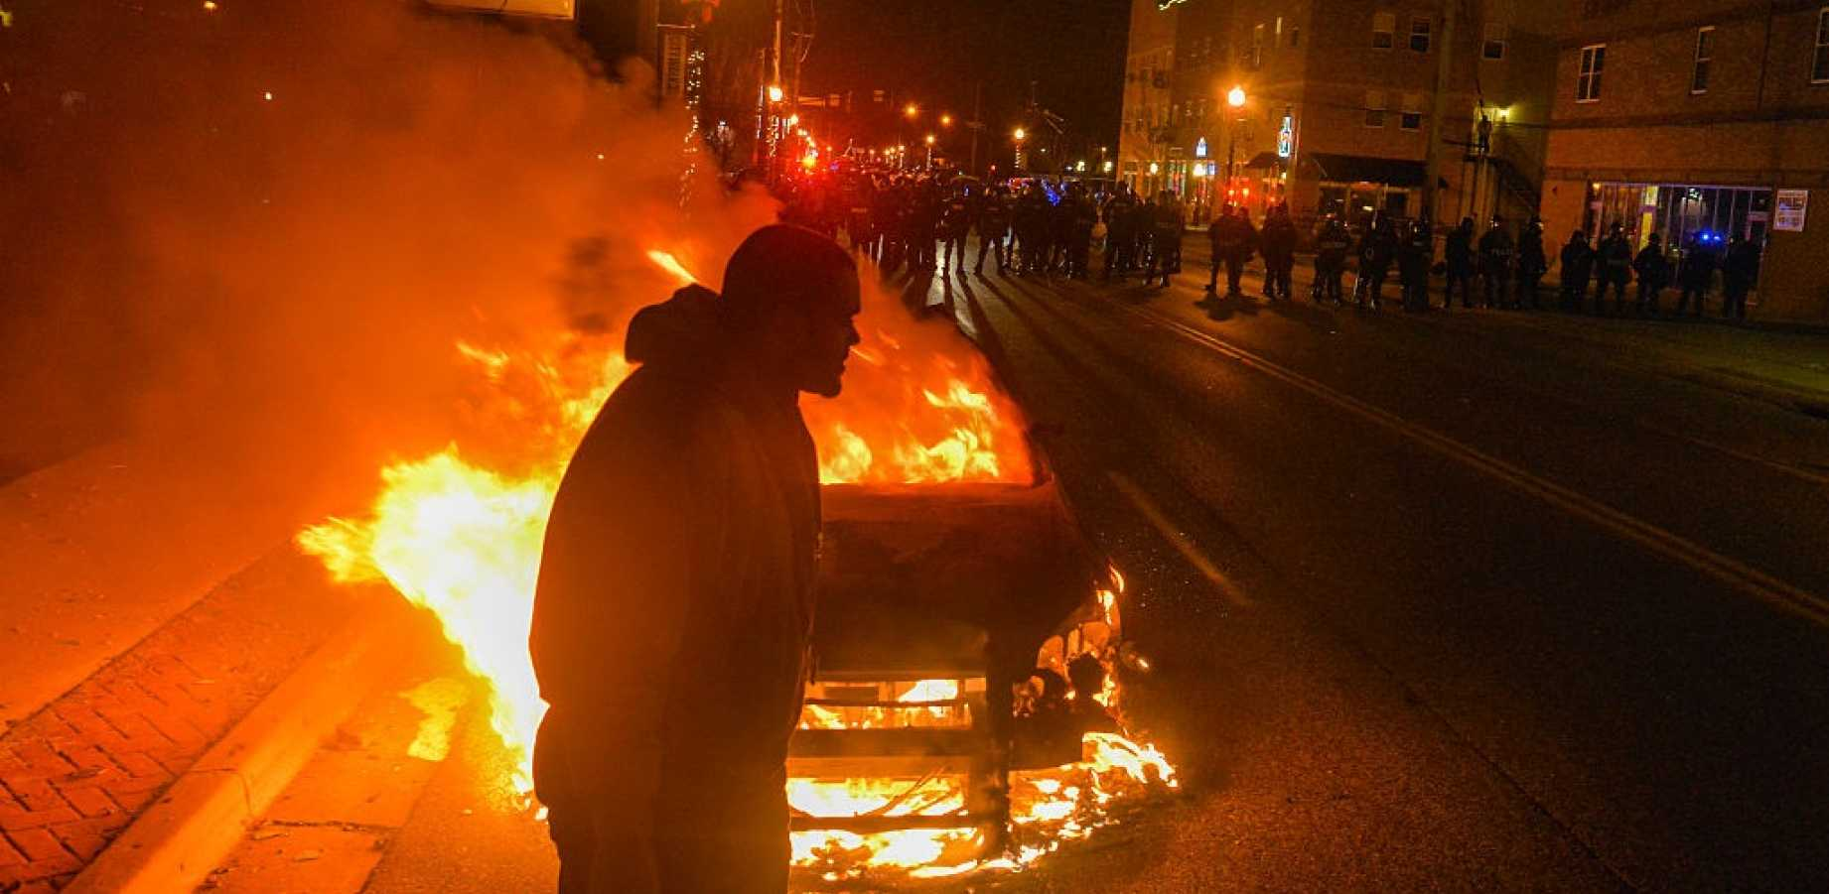

Any who are watching in disgust at the left’s weird semantics know well that what they are doing is entirely nonsensicle as this article by Aaron Bandler points out.
The left has a bad habit of allowing their protests to descend into rioting and violence, particularly over the last several years. Whether it's a police shooting or just being angry about the democratic election of President Donald Trump, destructive riots seem to have become the status quo for the left's "demonstrations."

Take for example the riots in Oakland and Los Angeles after George Zimmerman was acquitted in the Trayvon Martin shooting. In Oakland, the protesters were chucking bottles and rocks at police officers and attacked a reporter, photographer and TV cameraman. They also slowed down traffic. In Los Angeles, numerous protesters vandalized cars and businesses as well as assaulted people on the street

There are too many instances to record in this Newsletter, but to conclude, notice the following from the above article;
Anti-Trump thugs attack Trump supporters in San Jose, CA. When Trump came to San Jose for a rally in June, the following occurred:
Protesters jumped on cars, pelted Trump supporters with eggs and water balloons, snatched signs and stole “Make America Great” hats off supporters’ heads before burning the hats and snapping selfies with the charred remains.
Several people were caught on camera punching Trump supporters. At least one attacker was arrested, according to CNN, although police did not release much information.

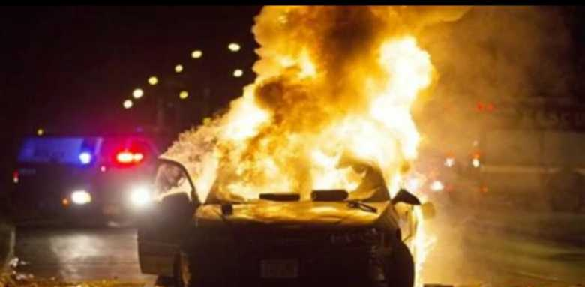
Riots in Milwaukee, WI after a black police officer shot and killed an armed black man. The rioters attacked police officers and journalists and set police cars, a gas station and a bank ablaze in flames.
If this is not an era of extraordinary Protests, VIOLENCE, Chaos and social Disorder what is??

Surely it is unnecessary to give any more examples of the protests, violence and anarchy, and yet with a final backward look, let us never forget, we are living through perilous times, as Paul wrote in 2Ti_3:1 This know also, that in the last days perilous times shall come. Because brethren, the times are set to get worse, much WORSE!

Take for example, The riots in Portland, OR, that ensued following Trump's upset victory in November were reportedly peaceful at first until an anarchist group joined in. The protesters/rioters quickly turned to breaking windows and throwing objects at police officers.
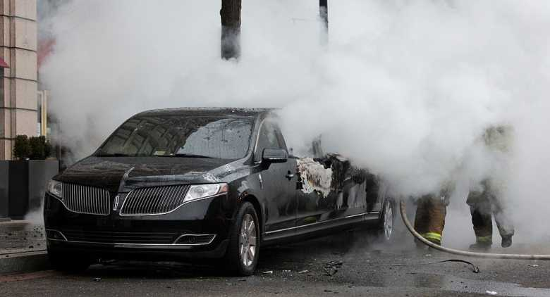
As well, the protests in Washington, D.C. on the weekend of Trump's inauguration were recorded as a slew of anti-Trump thugs assaulted Trump supporters, injured police officers by throwing bottles and rocks at them and set a limousine on fire!
Does that sound like a people motivated by wrongs, or perpetrating wrongs, as the scripture says, “doing evil that good may come”. (Rom.3:8.) In the only book that gives foresight and true wisdom in the face of all of this mayhem we find the following;

Isa 3:1 For, behold, the Lord, the LORD of hosts, doth take away from Jerusalem and from Judah the stay and the staff, the whole stay of bread, and the whole stay of water,
Isa 3:2 The mighty man, and the man of war, the judge, and the prophet, and the prudent, and the ancient,
Isa 3:3 The captain of fifty, and the honourable man, and the counsellor, and the cunning artificer, and the eloquent orator.
Isa 3:4 And I will give children to be their princes, and babes shall rule over them.
Isa 3:5 And the people shall be oppressed, every one by another, and every one by his neighbour: the child shall behave himself proudly against the ancient, and the base against the honourable.

Brethren, by the time this was written in about 700-750 BC, Israel had long blended in with the world, and had not had any mighty men, men of war, or prophets, and it wasn’t until the 1930’s some 2,500-2,600 years later did we begin to see a strong leader in the form of Winston Churchill.

Additionally, we can read many proofs that the inspired scriptures relate not only to ancient Israel, but to “Modern-Israel” in successive eras leading right to the time of the end!

One such prophecy is related in Ezekiel.
Eze 14:13 Son of man, when the land sinneth against me by trespassing grievously, then will I stretch out mine hand upon it, and will break the staff of the bread thereof, and will send famine upon it, and will cut off man and beast from it:

Was this only for Israel? Read the following.
Eze 14:14 Though these three men, Noah, Daniel, and Job, were in it, they should deliver but their own souls by their righteousness, saith the Lord GOD.

Noah was not an Israelite, but was lived approximately 3,000 BC, long before ever there was a nation of Jews.
Job he lived approximately 1500-1530 years BC.
Both of these men as well as Daniel, were extraordinary men who lived and served as examples of how to live righteously and faithfully before God.

PROPHECY FOR OUR TIMES

The fact that these prophecies are for our time is clear, and many of the chapters in these books record both ancient times, our time, and “end-times” before during and after the time of Jacobs trouble, but this chapter was primarily written for our time!

Viewing the events of today’s violent and angry world, we see other verses coming to life in the generation we are living through today in for example, Isaiah chapter 3;

Isa 3:9 The shew of their countenance doth witness against them; and they declare their sin as Sodom, they hide it not. Woe unto their soul! for they have rewarded evil unto themselves.

Isa 3:10 Say ye to the righteous, that it shall be well with him: for they shall eat the fruit of their doings.
Isa 3:11 Woe unto the wicked! it shall be ill with him: for the reward of his hands shall be given him.
Isa 3:12 As for my people, children are their oppressors, and women rule over them. O my people, they which lead thee cause thee to err, and destroy the way of thy paths.

Children have been oppressing God’s people in various ways for decades, due to weak and compliant parents who don’t stand for values, morals, etiquette, order and discipline!
In reality, it all began after WW1, when the world began to digress, and aby the time WWII ended, everyone was understandably sick of war, and instead of learning from the lessons of history, they repeated their mistakes, in rejecting God, not knowing it was the God of Jacob that rescued them out of certain death and destruction at the hands of their enemies!
That said, they were warned in those two world wars, just as ancient Israelites were. Both ancient and modern Israel have all REJECTED God to a man, and now Israel and the nations whom they should have been the greatest example to are set on a collision course with destiny, in their destruction!!

As for leadership, the last we read of strong masculine leadership in Israel is back in the book of the Joshua, chapter 24, where the servant of The LORD warned them repeatedly, as did Moses before him, to fear The LORD, and obey and serve Him in sincerity and in truth, and to put away the gods which their fathers served on the other side of the flood, and in Egypt.
These 2-examples should have served to remind them of the tremendous penalties mankind suffered, but, mankind only seems to understand force!

As for our western Israelitish nations today, God’s prophecies are as alive today, as they were when they were written, and the words of The Lord by the mouth of Isaiah have special significance for us in this age, given they are coming to life as they have never done before in our modern seething 20th and 21st centuries!

WHY HAVE USA’S PEOPLE BECOME SO ANGRY, VIOLENT, & NARCISSISTIC?

If you hadn’t already noticed, and I’m sure you have, at least to some degree, the United States has become overpopulated with an angry-left, violent Self-absorbed & virulent people! Could this have happened overnight because of Trump’s win?
No way! But I’ll address this later in the newsletter.

I say angry-left as opposed to angry-right, because when the right become angry, they are by-and large pretty peaceful in their disagreement, maybe not always, but mostly, and when the ‘left’ pendulum swings the way of the left, the right although unhappy, know there is no reasonable way to not accept the result.

That cannot be said about the left! On the contrary, the left REFUSE to accept anyone else’s view except their own, a most amazing situation indeed, but then again, that’s what the elite in our societies think they’re entitled to, without questions from anyone! If you don’t believe me, just try to give your opinion to a professor, or university lecturer anytime, and you might change your opinion.

Of course what a great deal of this boils down to is human-nature! That old problem, again, and again, and again, as a wise man once said; “Like a Jack in the box, it just continually pops it’s head up, again and again”, or words to that effect.

We see it here in Australia, on the daily news, on the radio, in the Parliament with the screaming left of politics DEMANDING the rights of their workers, (many of whom are “gay”.) and of the poor who need the extra money doled out to them for no work in return, so they can buy more cigarettes, or alcohol perhaps. Not that there aren’t genuine cases of people in need, and they should be helped, just not in the way they are DEMANDING as part of their RIGHTS!

The divisions in every sphere of human-life are almost incalculable, and among “professors” & scientists for instance, they have scientists for and against so-called climate change, where they coming out against even their own scientific community that disagree with them on “global-warming”, but the simple fact is that none, NONE of what the climate change, the elite, which are the political class, the professors, or anything in politics say or do, makes sense at all!
Little wonder our God asked the following question through Job;

Whence then comes wisdom? and where is the place of understanding? Seeing it is HID from the eyes of all living, and kept close from the fowls of the air. (Job.28:20-21)

TWISTED LEFT “VALUES”

I guess I’m too dumb to comprehend such great things in my little mind, but the thing that is obvious since Mr. Trump began running for office, the left hate him, and as much as we see the left in all their glory in politics, Trumps election appears to have hi-lighted their vitriol more than any other single issue today!

Following on from there, the Brexit vote has ignited the divide in Britain and in Europe, just as the President of Turkey who recently won the vote to have more executive powers since his purge in Turkey of Journalists, teachers, the military, lawyers and many others because of the Coup, has also shown at least half of Turkeys population do not agree that giving President Erdogan these executive powers makes sense at all and are now protesting.

Oh, and I read recently that the USA, have fallen prey to teaching their citizens about Muslim prayers! Did you know that? Maybe you did, maybe you like me you didn’t know. In fact I thought they, the Muslims, had their own schools. But the amount of undermining going on right under our very noses must be greater that anything we can imagine, like the tip of the proverbial iceberg!

The president of the Christian Action Network said his group found that the Department of Education (DOE) is funding thorough lesson plans on the Islamic faith. I believe that should be on the Islamic beliefs system, rather than faith.

Anyway, Martin Mawyer said that, through PBS, the DOE is disseminating materials that allow “teachers” to quiz students on what Muslim prayers sound like and what prayer movements look like. Brethren, they are not teachers, they are Muslim propaganda agents of evil, you know that, they don’t, but it’s like the proverbial slow moving train. It moves off sometimes so slowly, you don’t even know you’re moving till it’s already speeding along.
The analogy is that when different nationalities and cultures are allowed to enter our nations, they bring with them all their “beliefs” and slowly, bit by bit, they gain traction in our societies to the point that the citizens of each nation embrace their religious and cultural differences, from different dress and social differences in manners and etiquettes, to morals and foods. You see, to the world diversity is the key!
No brethren, diversity is not the key, because God said so!!
Deut. 32:7 Remember the days of old, consider the years of many generations: ask thy father, and he will shew thee; thy elders, and they will tell thee.
Deut. 32:8 When the most High divided to the nations their inheritance, when he separated the sons of Adam, he set the bounds of the people according to the number of the children of Israel.

The fact that our “leaders” are paying for religious education by YOU, the taxpayer, is disgusting on its own, especially as it is without your say so.

But it’s not just in the U.S, but in Britain, Canada, Switzerland, Sweden, Holland, the Netherlands, Australia, New Zealand and who knows how many other infiltration centres which are indoctrinating our children, our towns, cities and nations!
But it’s been going on, like the slow-moving train for who knows how long!
And the fact that Judeo-Christian values have been under attack by leftist movements, gay rights, human-rights, etc, ect to the point that Israel are under constant attack by the E.U, and recently, by the U.S under Obama Bin-Laden!!

COMMONWEALTH V REPUBLIC

A shift that is very disturbing. Predictable, but nonetheless eerie given what is already replacing it, and you know what that is. And I’m not just talking about Islam, that’s a small part of what’s been going on in our Israelitish nations for decades!
No, what I’m talking about in a far larger & more horrifying way, is the staged break-down of the Judeo-Christian and Westminster system the Israelitish nations have operated under for centuries by the left! Here in Australia, there has been a left-centrist movement toward a Republic, and away from the British system of a commonwealth.
The definition of a Commonwealth country is as follows;
Formerly British Commonwealth. An association comprising the United Kingdom, its dependencies, and many former British colonies that are now sovereign states, including Canada, Australia, India, and many West Indian and African countries.

What’s replacing our centuries old systems, the “values” or lack of them, of all the nations around us, and who are screaming and forcing their way into our societies, and Parliaments?
The “rights-Protestors” through the ideology of liberalism!
In the Bible God calls it “Every man doing that which is right in his own eyes!” (Judges.21:25) In other words, human CHAOS and confusion!
The apostle James said it this way;
Jas.3:16 For where envying and strife is, there is confusion and every evil work.

That’s the effect, the cause is as Paul referred to it in 1Cor.14:33 For God is not the author of confusion, but of peace, as in all churches of the saints.

In the churches of the saints, there should be peace, because they are to be ONE in The LORD, not all DIVIDED against one another as the world they have come out of!
Is that what we see in the churches? No! What does that tell us? Well, they are divided one against another, yes.
They are also in confusion, and the fact that whatever happens out there in the world usually happens within the church in a small matter of time.

This also is a result in part to Liberalism!

So what is Liberalism? That’s a big question!

Let me give you some quotes from a book called “SUICIDE OF THE WEST” by James Burnham.

In these quotes and excerpts I want us to piece together the picture as Mr. Burnham paints it, as I obviously can’t write pages and pages of quotes.

Chapter XV; LBERALISM vs REALITY Page:278 In its historical practice as well as it’s ideological doctrine, liberalism has always operated most naturally as a tendency of opposition to the prevailing order, to the status quo…the establishment in general or in its several parts.
Bottom of page;
Under its banner reform movements labored successfully to do away with many of the features of the old society or to transform them beyond recognition: many of the bad features, and also of course some of the good features, because liberalism’s impulse to tinker with the established order is quite general…….

Page.279
Liberalism, applying its usual remedies of education and democratic reform seasoned with optimism concerning human nature, has signally failed to get rid of crime and criminals, or even to lessen the frequency of their occurrence. Liberalism even fosters new sorts of crime through its permissive approach to education and sicipline and its provocative egalitarianism; (Classlessness)

Some, at least of our fearfully multiplying juvenile delinquency is the logical outcome of liberal principals. In a way, a juvenile delinquent is a youth who takes literally the progressive-educational stress on self-expression and freedom. Nor is our high percentage of multiple offenders much of an endorsement of the liberal schemes for re-educating criminals and giving them plenty of social service along with easy paroles. I have yet to read the account of one of those terrible crimes of sex perversion that take place daily, wherein the savage who rapes and strangles the child or grandmother or both did not have a long record of offences which in pre-liberal days would have kept him behind solid bars.

Page.282
The liberals have no replacement for the structure they have so enthusiastically helped to tear down. The vacuum is filled first by chaotic social churning and then, if a qualified dictator doesn’t come along to pick up the pieces, quite probably by communism, which does have a method, a will and an apparatus to bring about a reconsolidation on a anew foundation. This indicates why the liberal program is the communist program at a preliminary stage in the dialectical unfolding revolution.

All ideologies at every stage in their careers distort reality in some degree,……..This was the case with the older liberalism of the nineteenth century and the early years of our own. But the liberal ideology has by now got so far out of touch with fact that through its lens it has become impossible to see reality, much less to act positively on reality.
Pg 283 …………….The liberal flight from reality is headlong on every front.

What are the crucial present challenges to Western civilization? ……….

The crucial present challenges are I believe, three: First the jungle now spreading within our society, in particular in our great cities; Second, the explosive population growth and political activization within the worlds backward areas, principally the equatorial and sub-equatorial latitudes occupied by non-white masses; Third, the drive of the communist enterprise for a monopoly of world power.

Looking through the glass of liberalism, it is impossible, I repeat to see these challenges clearly. And liberalism apart, it cannot be easy for people like the author and most readers of this book, who lead, whether aware of it or not, lives carefully sheltered from social horrors, to comprehend the reality of our domestic jungles.
Page 287.

Liberalism cannot either see or deal with the domestic jungle and the backward regions - the two challenges are closely similar
Page 289.
James Burnham says that Jules Monnerot, one of the most remarkable writers on the serious issues of our time, summed up some years ago the wests discouraging dilemma in the fight against COMMUNISM! The left is infected with it, and the right cannot understand it.
Liberalism is infected with in the quite precise sense that communism and liberalism share most of their basic axioms and principals, and many of their values and sentiments.
Page 291
Thus, in relation to the struggle against communist enterprise, the principals of modern liberalism point inexorably toward to the conclusion that has been brought to the surface by the younger people in the ‘pacifist’ and disarmament movements: Better Red than Dead!

_____________________________________________________________________

P.O. Box 4222, VIC, Australia 3350 Ph: (+613) 5334 3855 e: eldergcve@gmail.com
_____________________________________________________________________

In Christ's name and service,

Mr. Peter J. McGilligan
Minister

